Project Planning Phase
Project Planning Template (Product Backlog, Sprint Planning, Stories, Story Points)
Date | 13 July 2026
Team ID
Project Name | Voice-Based Concept Understanding Analyzer (VBCUA)
Maximum Marks | 5 Marks
Product Backlog, Sprint Schedule, and Estimation (4 Marks)
Use the below template to create the product backlog and sprint schedule.
Sprint | Functional Requirement  (Epic) | User Story  Number | User Story / Task | Story  Points | Priority | Team Members
Sprint-1 | Audio Upload | USN-1 | As a student, I can upload a recorded audio file of my spoken explanation so that it can be evaluated. | 3 | High
Sprint-1 |  | USN-2 | As a student, I want unsupported audio file types to be rejected so that I only upload a file the system can process. | 2 | Medium
Sprint-1 | Speech-to-Text  Transcription | USN-3 | As a student, I want my audio automatically transcribed into text so that I can see what the system understood from my explanation. | 5 | High
Sprint-2 |  | USN-4 | As a student, I want to be notified if transcription fails so that I know to re-upload my audio. | 2 | Medium
Sprint-1 | Reference Answer  Management | USN-11 | As an evaluator, I want the system to use a stored reference answer for comparison so that grading is based on a consistent standard. | 3 | High
Sprint-1 | Semantic Similarity  Analysis | USN-5 | As a student, I want my transcript compared against a reference answer so that my understanding can be measured objectively. | 5 | High
Sprint-1 | Concept Understanding  Scoring | USN-6 | As a student, I want to receive a grade (Excellent / Good / Fair / Needs Improvement) so that I can quickly gauge my performance. | 3 | High
Sprint-1 |  | USN-7 | As a student, I want written feedback explaining my grade so that I understand what to improve. | 2 | Medium
Sprint-1 | Results Display | USN-8 | As a student, I want to view my transcript, score, and feedback together on one screen so that I can review my performance at a glance. | 3 | Medium
Sprint-2 |  | USN-12 | As an evaluator, I want each submission to show a clear grade tier so that I can quickly identify students who need support. | 2 | Medium
Sprint-2 | PDF Report  Generation | USN-9 | As a student, I want a PDF report of my assessment generated automatically so that I can keep a record of my performance. | 5 | Medium
Sprint-2 | Report Download | USN-10 | As a student, I want to download my PDF report so that I can save or share it. | 2 | Medium
Project Tracker, Velocity & Burndown Chart (4 Marks)
Sprint | Total Story  Points | Duration | Sprint Start Date  (Planned) | Sprint End Date  (Planned) | Story Points Completed  (as on Planned End Date) | Sprint Release Date  (Actual)
Sprint-1 | 26 | 6 Days | 01 Jun 2026 | 06 Jun 2026 | 26 | 06 Jun 2026
Sprint-2 | 11 | 6 Days | 08 Jun 2026 | 13 Jun 2026 | 11 | 13 Jun 2026
Velocity:
Velocity is the amount of work (in story points) a team completes during a sprint. The average velocity (AV), expressed as story points completed per day, is calculated as:
Average Velocity (AV) = Total Story Points ÷ Sprint Duration (days)
For Sprint-1: AV = 26 ÷ 6 ≈ 4.3 story points per day. For Sprint-2: AV = 11 ÷ 6 ≈ 1.8 story points per day. The lower velocity in Sprint-2 reflects the smaller scope of the remaining stories (error handling, report generation, and download) compared to the core transcription and scoring pipeline built in Sprint-1.
Burndown Chart:
A burndown chart is a graphical representation of work remaining versus time. It is commonly used in agile software development methodologies such as Scrum to track a team's progress toward completing a sprint, though it can be applied to any project with measurable progress over time.
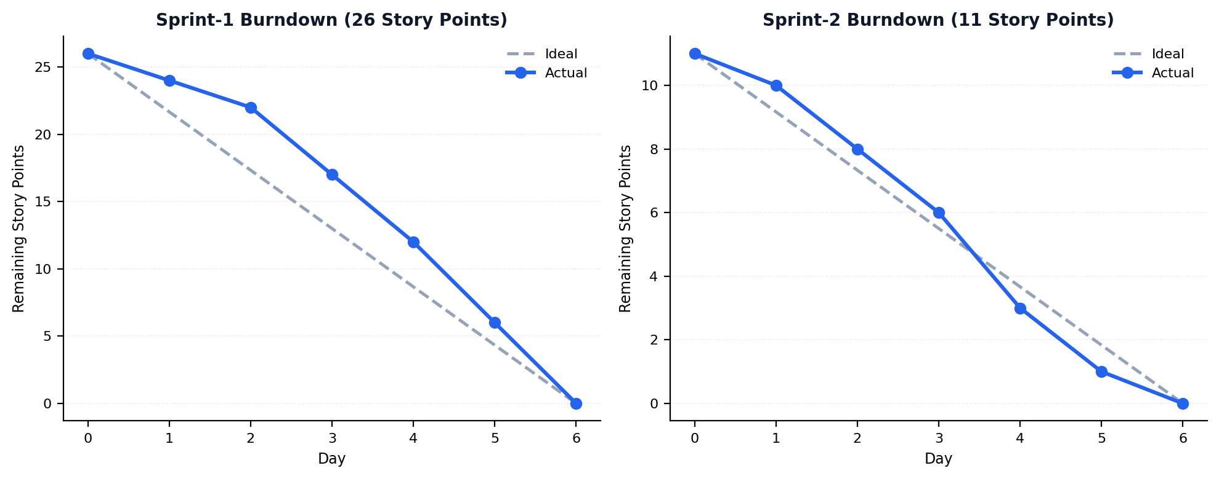
Figure 1: Sprint-1 and Sprint-2 Burndown Charts — VBCUA

